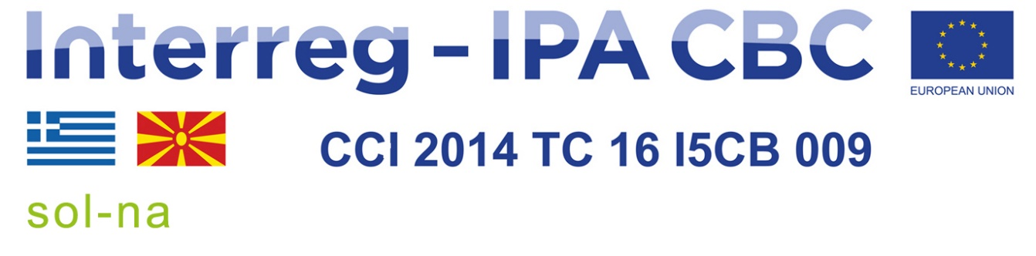
Letter of invitation to tender
Our ref.: 05-327/1 Skopje, 1 November 2022

Subject: Invitation to tender for Reproduction of communication and informative material
Dear Madam/Sir,

I am pleased to inform you that you are invited to take part in the single tender procedure for the above supply contract. The complete tender dossier includes:
- Instructions to tenderers & Contract notice
- Draft contract and special conditions, including annexes
- Draft contract
- Special conditions
- Annex I: general conditions
- Annex II + III: technical specifications + technical offer (to be tailored to the specific project)
- Annex IV: budget breakdown (model financial offer)
- Further information
- Administrative compliance grid
- Evaluation grid
- Tender form for a supply contract and Declaration on honour on exclusion and selection criteria (annex A14a)
Only the candidates receiving this invitation letter may submit a tender. Any tender received from a legal or natural person not invited to tender will be rejected.
For full information about procurement procedures please consult the practical guide and its annexes, which can be downloaded from the following web page: http://ec.europa.eu/europeaid/prag/document.do
We look forward to receiving your tender which has to be submitted no later than the submission deadline mentioned in the Contract Notice.
By submitting a tender you accept to receive notification of the outcome of the procedure by electronic means. Such notification shall be deemed to have been received by you on the date upon which the contracting authority sends it to the electronic address you referred to in your offer.
If you decide not to submit a tender, we would be grateful if you could inform us in writing, stating the reasons for your decision.
Yours sincerely,

Novica Zecevic, Director

